A91-Eur-Italy-Magna Graeca-Demeter-6th-5th cent. BCE

Magna Graeca Terracotta Figurine, Seated Demeter, 6th-5th century BCE. Original black pigment can still be discerned in outlining her eyes, hands, legs and hair. Round firing hole on base. 10.89 cm. (4.29 in.) high; 78.9 gm. (2,78 oz.).

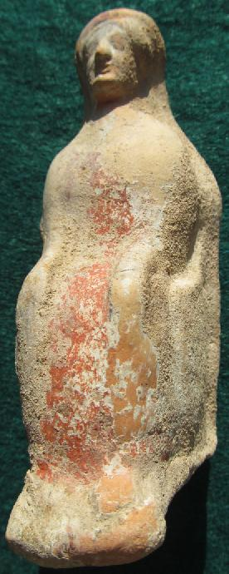 SHAPE \* MERGEFORMAT 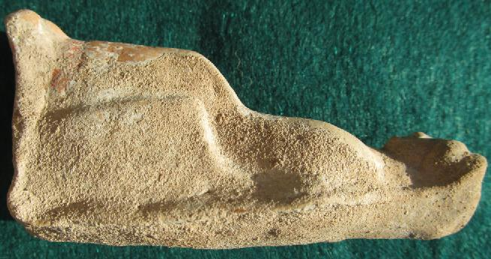 Case No.: 4

Formal Label:

**Display Description:**

Accession Number:

LC Classification: NB.150.R57

Date or Time Horizon:

Geographical Area:

Map,

GPS Coordinates:

Cultural Affiliation:

Geographical Area:

Medium:

**Dimensions**:   
**Weight:**

**Provenance**:

**Condition:**

**Discussion:**

**References:**

This terracotta figurine of a seated Demeter is from an area of southern Italy which was populated by Greek immigrants, hence it was called Magna Graeca. The immigrants who were responsible for this votary statuette of Demeter were fifth century BCE immigrants to Magna Graeca.

Demeter was one of three Greek deities (along with Artemis and Hera) who presided over childbirth. Girls and older women were lead by a priestess of Demeter, who was dressed in the garb of the deity. The entourage all carried terracotta figurines similar to this one as instruments of healing power, as Demeter's group went from domicile to domicile chanting songs to entreat the deity to intercede on behalf of young betrothed or married women for an easy labor. The Demeter cult therefore was originated by indigenous Greek women: it was not an exclusively agrarian fertility cult derivative of Oriental ideas as had been previously thought (Robertson 1974: 144). Now we are able to appreciate how figurines such as this one played a central role in the history of the empowerment of women as mid-wives in Classical Greece.

Where did these fifth century BCE immigrants to Magna Graeca come from who had such a high esteem for Demeter? We now know that the island of Cos (Κως), a Greek island off the Turkish mainland next to the Gulf of Gökova, was the source of Demeter devotees who were famous as mid-wives in the fifth century BCE. The worship of Demeter had begun in Cos in the Archaic period where it was thought to have been founded by the sons of king Eurypylus, Chalcon and Antagoras, who received the goddess as she roamed in search of her daughter Kore (Κόρη, the Roman Persephone). During the Pelopon­nesian War, Cos, a member of the Delian League and an ally of Athens, was captured and destroyed by Astyochus, the Spartan gen­eral. It was at this point that the cult of Asclepios was thought to have been brought to Cos by Dorians from Tricca in Thessaly (Sherwin-White 1978: 338). At this point two elements became intertwined: the cult of Demeter and that of Asclepios. Together they were essential in the administration of health care after the devastation of the Peloponnesian War.

The timing was fortuitous, because at this same period on Cos Hippocrates was practicing medicine and was conducting medical training out-of-doors under a famous plane tree. Besides establishing the ethical principles of the Hippocratic oath, he was a fervent exponent of observing the patient, documenting the symptoms, and teaching students at the bedside.We know from a dialogue in Aristophanes' *Thesmophoriazusae* that Hippocrates belonged to the Asclepiadai, a group of educated followers of Asclepios (Major 1941; Sherwin -White 1978:262), whose daughter, Hygeiea, was renowned as a healer. So, it was in keeping with his membership in the Asclepiadai that Hippocrates would have received women students in the art of healing and midwifery under the famous "Tree of Hippocrates," now a descendant of the original plane tree beside which is a tablet that reads

Hippocrates of Cos  
Under the shade of this plane tree  
Instructing and training the youth  
In the art and in the priesthood of medicine  
Instituted this oath  
In the fourth century B. C.

Only later in the fourth century BCE was the Asclepieion of Kos built on the site of an older temple to Apollo, approximately 4 km southwest of the city (Edelstein and Edelstein 1945; Temki 1953; Angeletti 1991; . Edelstein 1937; Bailey 1996). Rudolf Herzog the discoverer of the site in 1901 believed that an inscription he excavated is the founding inscription by Thessalus, who was the son of Hippocrates (Gibson 1966; Sakula 1984)!  The Asclepieion of Kos is one of the most beautiful island shrines in the Aegean.

Therefore, this statuette of Demeter by immigrants from Cos would have been an effort by these women to pay homage to their dual goddess, Hygeia-Demeter, from their homeland as the dual sources of medical training for women. In fact, Cos Demeter iconography (dating to the second half of the fourth century BCE) emphasizes her long strands of hair reaching to the shoulders and this is consistent with the iconography of the present figurine (Istituto Storico-Archeologico di Rodi 1928-41: 5(2): 160-161, Figs. 38-39). In addition, the present figurine wears a chiton indicated by a red slip over which is a long himation gown, which runs close to her body. Covered by a veil and with her long-flowing hair she projects an aura of serene, benevolent majesty: her feet are on a footstool, her hands are resting on her thighs as though listening to a suppliant patient.

Medical practice for women continued in Cos into the second century BCE, and a third century inscription records that the Demeter cult continued to be dedicated to "those [women] who are marrying and those who are being betrothed." It also indicated that the proceeds collected from the domiciles and people visited were to be used by the priestesses for ritual needs (Fraser 1972; 2:916-17, n. 290; Sherwin-White1978: 306). Such was the legacy of these figurines that commemorated a flourishing , ancient, gender inclusive medical practice.

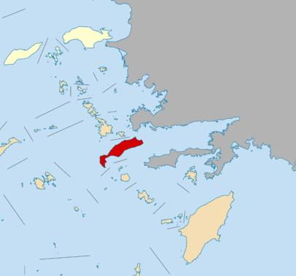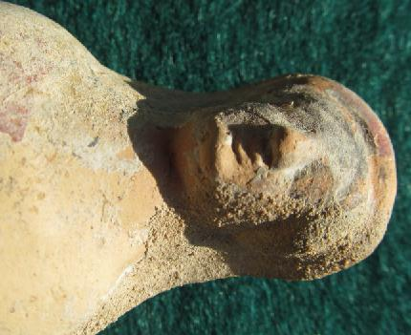



Island of Cos (Κως), where the Demeter mid-wife cult was extensively practiced, off the mainland of southwest Turkey, location [36°51′N 27°14′E](http://toolserver.org/~geohack/geohack.php?pagename=Kos&params=36_51_N_27_14_E_type:city_region:GR).

References:

Angeletti LR. Views of classical medicine. Theurgical and secular rational medicine in the healing-temples of ancient Greece. FORUM Trends Exp. Olin. Mad. 1991; 1: 211.

Bailey JE. Asklepios; ancient hero of medical care. Ann. Intern. Medicine. 1996; 124: 257263.

Edelstein L. Greek medicine in its relation to religion and magic. Bull. Hist. Mad. 1937; **S:** 201-246.

Edelstein EJ and Edelstein L. Asclepius; a Collection *and Interpretation of the* Testimonies. Baltimore: The Johns Hopkins Press, 1945.

Fraser, P. M. 1972. *Ptolemaic Alexandria*. Oxford: Oxford University Press.

Gibson W.S. 1966 Hippocrates' home. Journal of the American Medical Association 197: 110-113.

Istituto Storico-Archeologico di Rodi. 1928-41. Clara Rhodos. Studi e materiali pubblicati a cura dell'Istituto. Rodi, 1928-41.

Major, Ralph H. 1941. Hippocrates on the Island of Cos, *Yale Journal of Biology and Medicine*, 14:1-11.

Robertson, Noel. 1983. Greek Ritual Begging in Aid of Women's Fertility and Childbirth, *Transactions of the American Philological Association*, 113: 143-169.

Sakula A**. 1984.** In search of Hippocrates: a visit to Kos. Journal of the Royal Society of Medicine, 77: 682-688.

Sherwin-White, Susan M. 1978. *Ancient Cos: an historical study from the Dorian settlement to the imperial period.* Göttingen : Vandenhoeck und Ruprecht

Temkin O. Greek medicine as science and craft. Isis 1953; 44: 213-226.

sherwin-White

